2026 RCLL Registration Information

Online Registration Only
- Registration is available at www.rclittleleague.com.
- If you need help with online registration or have division questions, email rotterdamcarmanll@gmail.com.

Payment Options
- Credit/Debit Card (online only)
- To arrange cash/check payment, email: rotterdamcarmanll@gmail.com.

Registration Fees
- Majors / Minors / Farm: $175 per player
- Modified / T-Ball: $150 per player
All fees include $50 in raffle tickets (distributed by team managers). Families will receive 10 raffle tickets, they can sell these tickets for $5 each. Money made through sales is kept by the family.
Sibling discount: $30 off each additional player
Late registration (after Feb 16, 2026): $25 additional per family

Division Guide (Based on Little League Age as of 8/31/26)
T-Ball (Ages 4–6) - Age 6 players typically placed here only if new or needing additional development.
Modified (Ages 5–7) - Recommended after at least one year of T-Ball, age 7 players placed here only if further development is needed.
Farm (Ages 7–9) - Age 9 players placed here only if additional development is needed. (9-year-olds in Farm are not eligible for 8U All-Stars.)
Minors (Ages 9–11) - Age 11 players placed here only if developmentally appropriate, and age 12 may play with a signed waiver. (11-year-olds in Minors are not eligible for Minor All-Stars.)
Majors (Ages 11–12) - All placement decisions prioritize player safety and skill level.
If unsure of the correct division, please email rotterdamcarmanll@gmail.com.
- Continued on next page

Required Documents for New Players
(Only required upon request or if selected for All-Stars. Uploading during registration is optional)
- Original Birth Certificate (raised seal), and
- Three Proofs of Residency dated between Feb 1, 2025 – Feb 1, 2026.
Acceptable documents include driver’s license, utility bills, school records, medical records, insurance documents, homeowner/tenant records, municipal or state records, financial/employment records, military/veteran records, internet/cable statements, voter registration, or support/welfare/childcare records.

Player Assessments (Assessments help with fair and safe team placement)
Required for:
- All Farm players
- All new players to RCLL entering Minors or Majors
May be required as determined by RCLL Board for:
- Any 10-year-old requesting to play Majors

Manager Applications
Individuals wishing to be considered for a managerial position must submit a manager interest request by January 31, 2026 to cquinlivan725@outlook.com and rotterdamcarmanll@gmail.com.

Contact Information
Player Agents: Andy Quinn/Josh Countermine - rotterdamcarmanll@gmail.com
Tom Henges - dc2154@aol.com

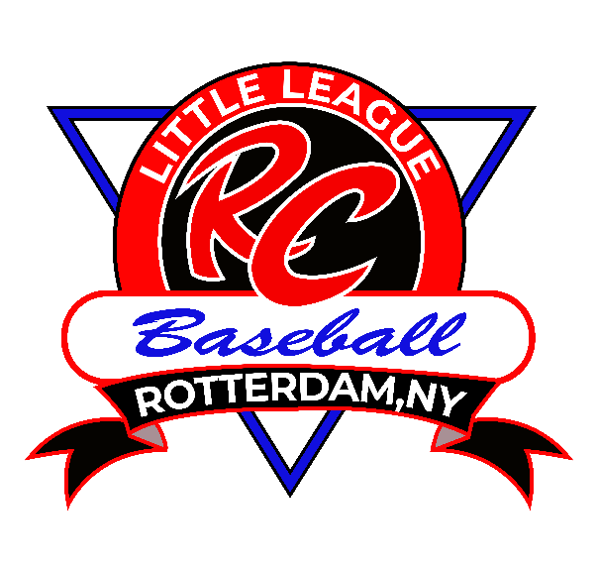

2026 RCLL Division Registration Information
The information below is intended to help families select the appropriate division for the upcoming season. If you have questions about your child’s placement, please contact an RCLL Player Agent (details below).

Determining Baseball Registration Age for Spring 2026
- Your child’s age on August 31, 2026, is their official Little League Baseball Age for the season.
- Baseball Age is an important factor in determining the correct division for both safety and competitive fairness.
- Please note that some players may play the entire spring season at their chronological age, but their Little League age would be one year older (example- summer birthdays). The 8/31 birthday cutoff rule is set by Little League International and becomes especially important for All-Star eligibility.

Age Group Levels of Play
Placement recommendations are based on Little League Age as of August 31, 2026. All placements prioritize player safety and skill level.
T-Ball (Ages 4–6) - Age 6 players typically remain in T-Ball only if they are new to baseball or need additional skill development.
Modified (Ages 5–7) - Ideally for players who have completed one year of T-Ball (exceptions may apply). Age 7 players remain in Modified only if new to baseball or requiring further development.
Farm (Ages 7–9) - Primarily for Baseball Age 7 and 8 players. Age 9 players may be placed here if additional development is needed. 9-year-olds in Farm are not eligible for 8U All-Stars.
Minors (Ages 9–11) - Generally suited for Baseball Age 9 and 10. Age 11 players may play Minors if appropriate for their skill level. Age 12 players may participate with a signed waiver. 11-year-olds in Minors are not eligible for Minor All-Stars.
Majors (Ages 11–12) - Intended primarily for Baseball Age 11 and 12. Advanced 10-year-olds may be considered based on skill and safety. Families must email RC Player Agents to begin the evaluation process. Playing up does not guarantee All-Star selection.
Skill Assessments (Assessments help ensure safe, fair, and appropriate team placement) - Required for all Farm players, new Minors/Majors players, and any 10-year-old requesting to play in Majors.

Contact Information
RCLL Player Agents: Andy Quinn/Josh Countermone - rotterdamcarmanll@gmail.com and Tom Henges - dc2154@aol.com

